- Introduction

This report on Responsible Investment (RI) is a companion to the LPPI RI Dashboard and the Quarterly Active Ownership Report. It covers stewardship in the period 1 July to 30 September 2020 plus insights on current and emerging issues for client pension funds.

R This symbol indicates a term explained in the reference section at the end of this report.

Key takeaways for the period:

- LPPI has published a first Annual Report on Responsible Investment 2019/20 as a supplement to the LPP Annual Report and Accounts 2019/20.
- British American Tobacco has exited the Global Equity Fund (GEF) Top Ten holdings
- Investments in brown sectors (extraction, transportation, storage, supply, and generation of energy from fossil fuels) are 3.07% of the portfolio.
- Investments in green sectors (renewable energy generation, clean technology, and decarbonising activities) are 4.02% of the portfolio.
- LPPI has participated in annual client panels with the Robeco Active Ownership Team on material matters and priority areas for future engagement themes.

- RI Dashboard – portfolio characteristics

This section of the report shares key takeaways from the RI Dashboard at Appendix B.

Asset class metrics (Dashboard pages 1 & 2) offer insights on the composition of the portfolio and its general characteristics. There have been minimal changes compared with the position reported at Q2 2020.

Listed equities (Dashboard p1)

Sector Breakdown
Categorised by GICSR the largest sectoral exposures for the GEF are information technology (22%) and consumer staples (15%).

Comparing the GEF with its benchmark (MSCI ACWI) R gives insight into how sector exposures for the fund differ from a global market index. The length of each horizontal bar indicates by how much exposures differ in total (+ or –) compared with the benchmark, which is the outcome of active managers making stock selection decisions rather than passively buying an index.

The GEF is underweight energy (GEF 0.5% versus 2.8% for MSCI ACWI) indicating a much lower exposure to companies extracting, transporting, storing, and supplying fossil fuels.

Top 10 Positions
Microsoft was added to the GEF in Q2 and now features in the top 10 positions.
British American Tobacco (BAT) has exited the top 10 following the liquidation of shares held by the internal portfolio. The decision to sell BAT reflects a confluence of factors, principally the forecast future effects of a shift to lower harm products (nicotine-based alternatives and reduced-risk tobacco products). It is judged that the growth of such products could result in future ROIC (return on invested capital) being materially less than historic rates for the company due to:

- barriers to entry being lower than in traditional tobacco products
- a lower margin profile for potentially reduced harm products vs traditional tobacco
- the requirement to invest in and build new brands outside BAT’s historic brand portfolio.

In these circumstances, the intrinsic growth rate for the company may fall below that attractive to LPPI as a long-term investor. The concentrated nature of the internal portfolio means competition for capital is high and conviction in the risk/reward trade off from existing holdings, versus alternatives in the investment universe is continually being assessed.

Portfolio ESG Score
The GEF’s Portfolio ESG score has risen slightly from 5.3 (Q2) to 5.4 (Q2). This continues to be a higher (better) score than the equivalent score for the benchmark, which is steady at 5.2 (unchanged from Q2).

Transition Pathway Initiative (TPI)
Measurement against TPI R Management Quality ratings confirms the GEF has relatively low exposure to highly carbon intensive activities. By value, only 12.5% of the GEF is in companies under TPI assessment as global high emitters (unchanged from Q2).

Compared with Q2, the number of companies in TPI scope has increased by 3 (Q2 38, Q3 41). The change reflects 2 investments added to the GEF, one sold, and 2 investments already in the GEF which are now in TPI scope for the first time (under a refreshed dataset released by TPI).

Of the 41 companies in TPI scope:
- 95% (by value) are rated TPI 3 and above – demonstrably integrating climate change into their operational planning (TPI3) and strategic planning (TPI 4).
- all extractive fossil fuel companies are TPI 3 or above (100% compliance with LPPI’s target for this sector).

Other asset classes (Dashboard p2)

Private Equity
Sector and geographical exposures are unchanged from Q2. The portfolio has a strong US presence (47%) and largest sector exposure is to Information Technology (32%).
The Private Equity portfolio is the focus of Real World Outcomes this quarter (Dashboard Pages 6-7) Examples give a flavour of investments making a positive social contribution in addition to achieving returns for the Fund and focus on companies supporting health and wellbeing through medical services and healthier diets/a healthier planet through alternative foods.

Infrastructure
Sector and geographical exposures are largely unchanged from Q1. The portfolio is predominantly focussed within the UK/Europe (43% / 37%) and is 61% utilities (supply of power and water).

Real Estate
Sector and geographical exposures are unchanged from Q2.
The portfolio is 79% UK assets and has a 37% weighting to industrial uses (logistics).

Green & Brown Exposures
Calculation of the Fund’s exposure to Green and Brown activities focusses specifically on equity assets - listed equity, private equity, and infrastructure, plus green bonds within fixed income. The numbers give an indication, rather than a precise measure, as an assistance to reviewing the overall position. Our methodology continues to develop, particularly as we work to improve look-through to underlying assets held by pooled vehicles and fund of funds.

Green activities are those directly contributing to decarbonisation, principally through renewable energy generation, but we include other activities supporting lower emissions including district heating, and waste management. Brown activities are those directly involved with extracting, transporting, storing, and otherwise supplying fossil fuels, or using them to generate energy.

Overall levels of Green and Brown exposure show minimal change compared to Q2 2020. Brown activities are 3.07% (Q2 3.15%). Green activities are 4.02% (Q2 4.02%).

Brown exposure is 89% infrastructure and is mainly indirect investments in midstream and downstream oil and gas through infrastructure pooled funds. Midstream and downstream are collectively 66% of total brown exposure.

Green exposure is 98% infrastructure and reflects renewable energy generation from wind, solar, hydro, and waste which are collectively 85% of total green exposure.

Core Stewardship

This section of the report gives an overview of stewardship activities in the period.
Client pension funds delegate day to day implementation of the Partnership’s approach to RI to Local Pensions Partnership Investments Ltd (LPPI). Ongoing stewardship activities by LPPI include portfolio and manager monitoring and the exercise of ownership responsibilities via shareholder voting, and engagement.

Shareholder Voting - LPPI Global Equity Fund (GEF) (Dashboard page 3)

Shareholder voting is overseen centrally by LPPI rather than by individual asset managers. LPPI receives analysis and recommendations from an external provider of proxy voting and governance research. We follow Sustainability Voting Guidelines focussed on material ESG considerations and liaise with providers and asset managers as needed to reach final voting decisions.

Full details of all shareholder voting by LPPI is publicly available from the LPP website within quarterly shareholder voting reports.

The period July to September 2020 encompassed 74 meetings and 714 proposals voted.

- Company Proposals

LPPI supported 90% of company proposals in the period.
Opposition voting concentrated on
- the election of directors (addressing individual director issues, overall board independence, inadequate board diversity)
- non-salary compensation (addressing inadequate disclosure of underlying performance criteria, quantum of proposed rewards)

Insights – Director related
LPPI voted against three directors across two company meetings due to their poor attendance.
Bajaj Finance Limited (India: Consumer Finance)
Divi’s Laboratories Ltd (India: Life Sciences Tools & Services)
Parties failed to attend at least 75% of meetings in 12 months with no satisfactory reason for their absence. (Results: between 8.1% and 9.8% Against).

LPPI cast dissenting votes at two company meetings regarding a lack of gender diversity on the Board (no female board members). Opposition voting targeted directors in the Nominating Committee at Olympus Corp. (Japan: Health Care Equipment) and Muthoot Finance Limited (India: Consumer Finance).
(Results: Between 1.9% and 16.6% Against)

At HDFC Bank (India: Diversified Banks), LPPI voted against one director due to concerns of over boarding. (Result: 11.5% Against).

Insights – Non-salary compensation

LPPI opposed management in 11 “say on pay” votes across 8 company meetings.

Company | Results (Against)
Wendel SE (France: Multi-Sector Holdings) | 14.5% - 19.6%
Bajaj Finance (India: Consumer Finance) | 6.4%
Wizz Air Holdings Plc (UK: Airlines) | 51.6%
Titan Company (Jersey: Apparel & Luxury Goods) | 8.8%
Fisher & Paykel Corp (New Zealand: Healthcare) | 27.3%
Compagnie Financière Richemont (Switzerland: Apparel & Luxury Goods) | Not disclosed
Tele2 AB (Sweden: Wireless Telecommunication Services) | Not disclosed
Nike (USA: Footwear) | 46.0%

Reasons included a lack of challenge in bonus incentives, poor transparency on performance measures, and an award (under a long-term incentive programme) relating to performance prior to the executive joining the firm.

- Shareholder Proposals

Only 1 shareholder proposal arose across the company meetings voted by LPPI in Q3.
At Nike (USA: Footwear), shareholders submitted a proposal requesting the company to disclose more information about its political contributions. LPPI voted in favour. Whilst the proposal did not gain majority support, 34.4% of votes were in favour.

Shareholder Engagement

Company and manager engagements are underway on an ongoing basis, directly through board seats and Limited Partner Advisory Committees (LPAC) for private market assets, and more conventionally through shareholder engagement with listed companies.

LPPI’s engagement partner Robeco has completed a third full quarter of engagement activity. As part of the annual process of consulting clients on priorities for future engagement themes LPPI has participated in two client panels with Robeco in November, a first convened with LGPS clients (Robeco provide engagement services to 2 other LGPS pools) and a second including Robeco’s broader client base for engagement services. Collectively the insights shared will influence the long list of themes Robeco take forward for further work and eventually reduce to a shortlist for launch in 2021 and beyond.

The Active Ownership Report (available via the online Pensions Library) provides narrative on thematic engagements underway with listed companies (representing shares held by the Global Equities Fund, or corporate bonds held by the LPPI Fixed Income Fund).

RI Dashboard (page 4) provides engagement headlines which confirm the Robeco Active Ownership Team engaged with 40 companies in total, the predominant focus was environmental management. Robeco report that Covid-19 is not having a significant impact on the engagement programme in terms of their access to companies, with calls and virtual meetings providing a backstop where face to face dialogue is not possible.

The current status of each live engagement theme (as it stood at the end of Q3) is summarised on page 5 of the Dashboard in the table “Engagement Results per Theme”.

18 themes were live at the end of Q3. 4 themes (Sound Environmental Management, Sound Social Management, Good Governance, and Global Controversy Engagement) are evergreen, the remaining 14 are thematic and reflect priorities identified through a combination of Robeco research and client input. Each theme is scheduled to last approximately three years, with progress continually tracked against clear objectives.

One theme concluded during Q3 2020 and is not listed in the status report, the final outcome is shown below.

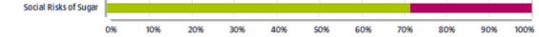

The social risks of sugar engagement spanned 3 years from 2017 to 2020.
The objective was to press for improved sustainability in the food and beverage sector with a special focus on innovation management, labelling, product reformulation, responsible marketing, and responsible lobbying.

The success rate was 71% for the 7 companies held by LPPI’s GEF (Coca-Cola, Danone, General Mills, Nestlé, PepsiCo, Kraft Heinz, Unilever). This reflects that for two of the seven companies engaged, insufficient progress across all 5 key asks meant outcomes were deemed not to have been met in full, but there was nevertheless positive progress in all companies.

Each quarter, we provide further insights into one of the live themes underway by the Robeco Active Ownership Team.

Case study - Single Use Plastics

Robeco introduced the Single Use Plastics engagement theme in 2019, as the negative externalities of plastic waste on marine biodiversity and human health via the food chain rose in public awareness.

Robeco recognise that plastic in and of itself is not negative, the low cost and environmental impact of production make it preferable to many alternatives. It is the lack of collection and recycling that drives negative impacts. These are materialising financially as governments seek to minimise harm through enhanced regulation, including product bans and taxes, and as consumer awareness and preferences shift, and the availability of substitutes and reputational risks grow.

The objective of the engagement is to drive the global plastic packaging value chain towards a more circular model, where plastics do not enter landfill or the oceans after one use, and the supply of and demand for recycled plastic improves. To achieve this, Robeco are targeting chemical companies upstream in the plastic value chain, and consumer facing companies with significant packaging footprints. The 5 companies under engagement for LPPI fall into the latter group and are as follows:
- Nestle
- PepsiCo
- Danone
- Procter & Gamble
- Henkel

Robeco have set five objectives for the engagement:

- Innovation management: encouraging innovation in packaging solutions.
- Plastic recycling: an expectation for all companies in the plastic value chain to take responsibility by investing in recycling infrastructure or enabling recycling at the point of sale.
- Plastic harmonisation: reducing the complexity of plastics used and working towards the harmonisation of different plastics to facilitate more efficient waste management.
- Responsible lobbying for regulatory change: an expectation that companies will support actions to make the industry more sustainable, rather than encouraging responses that minimise cost at their firm/position in the value chain.
- Industry collaboration and Public-Private Partnerships: an expectation companies will work transparently with other stakeholders, particularly in developing markets where recycling infrastructure is poor, and contribute to solutions.

Progress so far is neutral to positive, indicating no company has so far been resistant to these conversations, alongside examples of clear progress. Historically, the challenge for closing the loop of plastic use has been the fact that virgin plastics are cheaper and of better quality than recycled plastics. This is especially true in low oil price environments. However, companies are showing they are willing to pay a premium to source recycled plastics, highlighting their cognisance of wider stakeholder concerns and the potential for this to impact their bottom line.

- Collaborations and Partnerships

LPPI participates in a range of investor groups and partnerships which are opportunities for shared learning and a platform for collective action. The following are headlines for 2020 Q3.

Workforce Disclosure Initiative (WDI)

The WDI is a data and engagement platform which seeks to generate new metrics on key characteristics of workforce management (under ‘S’ within ESG). Having been an investor supporter since inception, LPPI became a paying supporter earlier this year when WDI shifted to an investor-funded model following the conclusion of pilot funding.

Building from a smaller pilot, WDI now sends an annual survey to 750 companies across major markets worldwide. Through it, WDI encourages companies to provide detailed disclosure on workforce matters. To encourage participation, investor supporters can engage with their holdings, persuading them to respond to the survey and disclose the prescribed data. As part of a coalition of investors, LPPI is engaging to encourage target companies who have not yet disclosed to begin to do so. Six companies held by the Internal portfolio have been selected for focus as follows:

Company | LPPI role | Response to date
Diageo | Lead | Success: commitment to participate
3M | Lead | No response at the time of writing
Nike | Support investor | Acknowledgement of letter. Discussed with lead investor/WDI
PepsiCo | Support investor | Acknowledgment of letter and discussion in email exchange.
Estee Lauder | Support investor | No response at the time of writing
London Stock Exchange Group | Support investor | No response at the time of writing

For two companies, LPPI is the lead investor. For the other four LPPI is a ‘support’ investor. Lead investors are the first to make contact after the WDI has shared the survey and requested disclosure. Typically, they play a more proactive role, for example, by joining calls with the company alongside the WDI. Support investors contact companies which have already received communications from other investors within the coalition, confirming the broader investor interest in them disclosing comprehensive workforce data through the WDI survey.

The importance of effective Human Capital Management has been highlighted by the experience of Covid-19 (the policies and processes which govern employer/employee relationships, contracts, and broader financial and personal welfare as part of corporate culture and governance). Requesting companies to disclose on their workforce policies and the outcomes of these is encouraging a broader availability of the type of information not widely available or on a comparable basis currently.

Investor Mining Initiative

In the wake of questions and concerns about the management of cultural heritage sparked by Rio Tinto's destruction of an ancient Aboriginal site in Australia, LPPI has signed a joint investor letter calling on mining companies internationally to demonstrate verifiable outcome-oriented processes and standards that will ensure that such events are not repeated.

The initiative has the support of 64 investors ($10.2tn) who are calling on investee companies for assurances about how they gain and maintain their social licence to operate with First Nations and Indigenous communities.

Further information on the initiative and the investor letter is available here.

LGPS Cross Pool RI Group

LPPI’s Head of RI completes her term as the Chair of the LGPS Cross-Pool RI Group in January 2021 when a new Chair steps in (the role is held in rotation).

In Q3 the group discussed the significant increase in reporting requirements associated with the implementation the revised UK Stewardship Code (2020) and the lack of clarity under current regulations and guidance on whether it is a requirement for LGPS Funds to be signatories to the Code or the requirement is to disclose their stewardship arrangements in line with the Code.

Guidance sought from the Local Govt Assoc (on behalf of Scheme Advisory Board) is that the latter may be presumed currently, but with the reminder that MHCLG has pledged to bring forward a package of amendments to regulations early next year, which are expected to include TCFDR reporting and which may also touch on this matter.

The LGPS Scheme Advisory Board has committed to appointing a Responsible Investment Advisory Group to advise on and support its work in this area.
The SAB Investment Committee met in October and agreed the RI Advisory Group’s terms of reference and membership profile as follows.
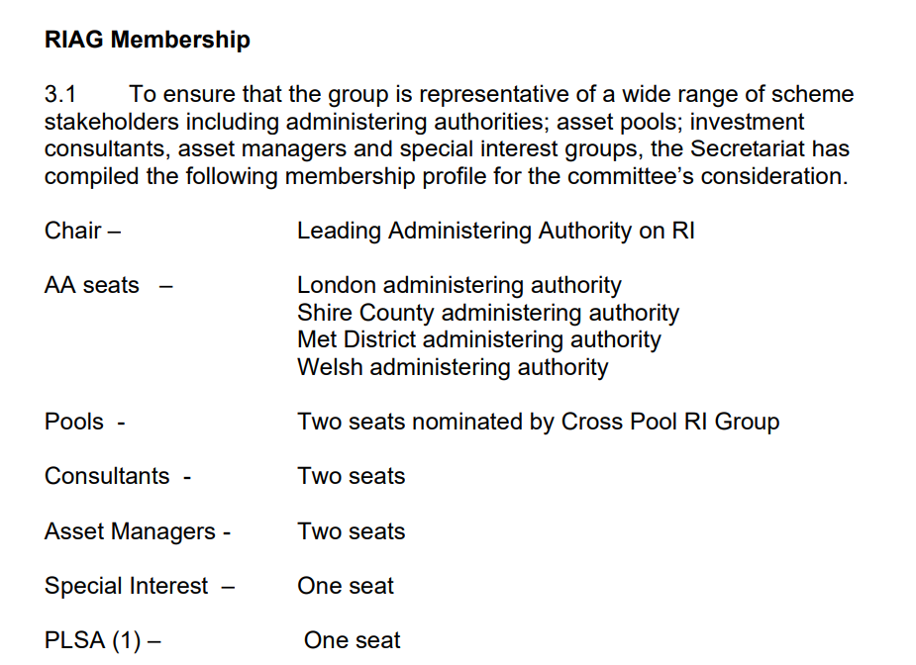
Further details of the meeting and proposals are available from the SAB website.

- Other News and Insights

LPP Annual Report on Responsible Investment 2019-20

LPPI has published a first Annual Report on Responsible Investment as a dedicated supplement to the LPP Annual Report and Accounts 2019/20. The report provides a review of the year to 31 March 2020 and incorporates LPPI’s disclosure in line with the recommendations of the Taskforce on Climate related Financial Disclosure (TCFD) R. It is LPP’s second TCFD report, the first having been produced for the period 2018/19.

LPP’s Annual Report on RI reflects a strong focus on improving communications about LPPI’s RI and Stewardship activities which recognises this is an area of growing interest for client pension funds and broader stakeholders.

The full report is available from the LPP website here.

For Reference

GICS - Global Industry Classification System
The most widely used approach to categorising activities into industry sectors. The main standard in use for public markets with growing use for other asset classes.
For more information on GICS and the activities that fall into each sector see:
https://www.spglobal.com/marketintelligence/en/documents/112727-gics-mapbook_2018_v3_letter_digitalspreads.pdf

MSCI ACWI - MSCI All Country World Index
A stock index designed to track broad global equity-market performance.
The LPPI Global Equity Fund’s benchmark.

MSCI - Morgan Stanley Capital International A global index provider.

TPI - Transition Pathway Initiative https://www.transitionpathwayinitiative.org/
The TPI assesses highest emitting companies globally on their preparedness for transition to a low carbon economy.
368 companies are rated TPI 0-4* for Management Quality based on 19 separate datapoints.
TPI Management Quality scores provide an objective external measure of corporate transition readiness.
TCFD - Taskforce on Climate Related Financial Disclosure
The Financial Stability Board created the Task Force on Climate-related Financial Disclosures (TCFD) to improve and increase reporting of climate-related financial information by companies and investors.
Recommendations include annual disclosure under 4 pillars:

